Welcome Club

April 28 2021~ 3:30pm-4:30pm

 Character lesson of the month:

Integrity- doing what’s right even when no one is watching

* Asking for permission

**3:30-3:35**

Introduction to Welcome Club  - Megan

-Build friendships

-Help each other

-Discuss problems and issues with coaches and students

-Have fun!

 *Review Welcome club’s foundation for how we treat each other: Treat others the way you want to be treated.

-**Transition**- (Coach Megan) “Ok let’s have the coaches introduce themselves and tell us what is your favorite board game?”

**3:35-3:40**

 Introduction of Coaches- We will take turns sharing our name and sharing your favorite board game.

-**Transition**- (Coach Megan) “Now I want to introduce our lesson for today.” Asking permission as a part of integrity

Introduction of Character Lesson- “Today we are going to talk about integrity and asking permission.

-**Transition**- (Coach Megan) “Let’s get into our breakout rooms and we can start with a game! Everyone make sure you have your Welcome Club bag and markers or crayons.”

**3:40-3:50**

- Coaches, start your group time by having each student introduce himself or herself and share what color they feel like today. Next, you will need to explain the rules of the game. Assistant coaches are encouraged to participate.

ICEBREAKERS  - Plate Game

Directions: Coaches will tell the students that they are going to try to draw a picture on their heads. Tell the students that it is okay if it look silly. Have the students put a paper plate on their head and try to draw a ‘cat’. Then have the student’s share what their picture looks like. Then have the students try to draw the picture again while looking at the paper plate. Repeat with a few more pictures: house, flower, ice-cream…

**-Transition-** (coaches) ‘Is it easier to draw the picture when you can see what is going on?’ We are going to talk more about integrity and thinking about other people’s perspective”.

**3:50-4:10**

 Lesson:    Integrity- Asking Permission

Coaches:

“Thinking about how others might feel is an important part of integrity. What does integrity mean? Integrity is doing what’s right even when no one is watching. Coach Megan talked earlier about how asking for permission make other people feel and gives us a chance to show integrity. You are going to hear a story about asking for permission and then we are going to talk about it.

*Coaches have the option of showing the video of Amy telling a story about asking permission or telling the story themselves and showing the pictures. Discussion questions and group discussion directions provided.*

**Transition**- “Now we are going to get out our slap bracelets and crayons. These bracelets can help us remember to ask permission”.

**4:10-4:30 Activity- Slap bracelets**

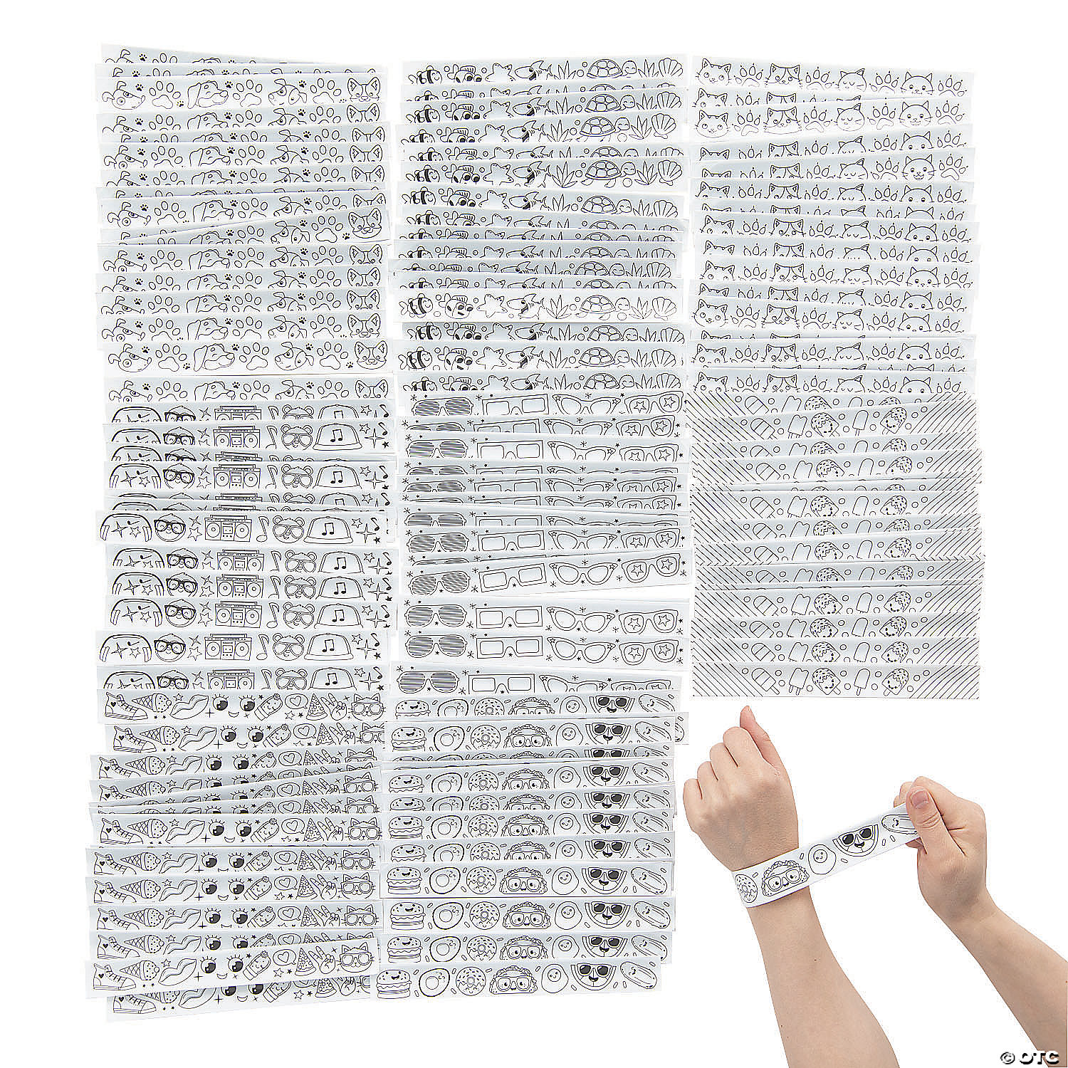

Students will color their own slap bracelets. This slap bracelet is a reminder to ask permission/raise their hand to ask permission.

Conversation starters and fun question ideas- Would you rather….

1. Would you rather have a pool or a trampoline?  
2. Would you rather be a doctor or a scientist?

3. Would you rather go to the zoo or an aquarium?  
4. Would you rather be really fast or really strong?  
5. Would you rather set the table before dinner or wash the dishes after dinner?  
6. Would you rather have pizza or chips?  
7. Would you rather have a pet hamster or a pet cat?  
8. Would you rather have kabobs or mantou?  
9. Would you rather ask your mom for permission or your dad?  
10. Would you rather ask for permission to go to the park or play video games?  
11. Would you rather ask for permission or have someone ask you for permission?  
12. Would you rather read minds or be invisible?

**4:30**

 Wrap up and Goodbyes

* Updates and information-

**\*Coaches stay on for quick debrief**

**Bag contents:**

Slap bracelets

Snack

Drink

Activity Sheets